**For in loop**

For in loop statement is used with **object** and **Array** data type.

**Remember that object syntax is :**

**Syntax of for in loop is:**

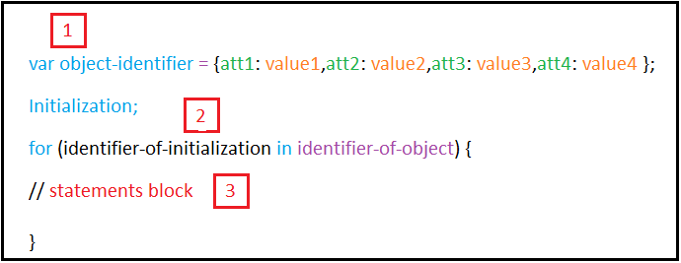

**Note:**

* Identifier-of-initialization in for in loop refers to object attributes.
* To show values of object attributes use [ ] where this brackets means “open” so when you say => identifier-of-object[identifier-of-initialization]. Means go to identifier-of-object open it and show what inside its attributes (object values).
* There is **no semicolon** in the end of for in statement.

**How for in loop keyword works?**

From the previous syntax we can see that for in loop keyword consist of 3 parts:

Part 1: object.

Part 2: initialization.

Part 3: for in block.

We will use imaginary arrow to show us the path of execution the code:

The path of this arrow is shown in this picture:

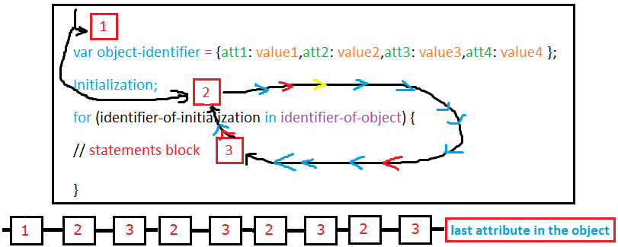

The arrow moves from 1 to 2 then to 3 and transfer again to 2 then 3 to 2 to 3 and stop after executing the last attribute in the current object.

**Note**:

1. Arrow passes to number1 only one time (when **entering** the for in keyword)
2. Loop path is expressed on numbers 2, 3.

**Example1:**

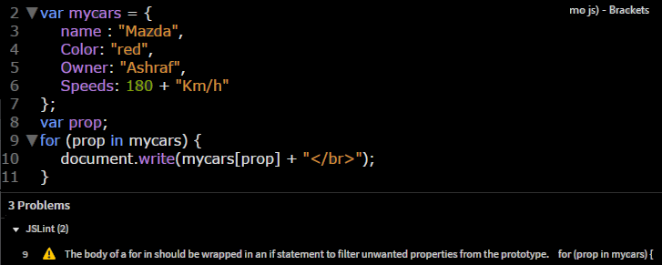

**Remember**: we use .hasOwnProperty to remove this error.

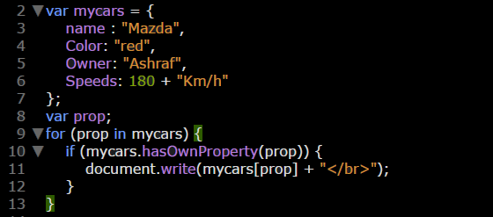

**Example2:**

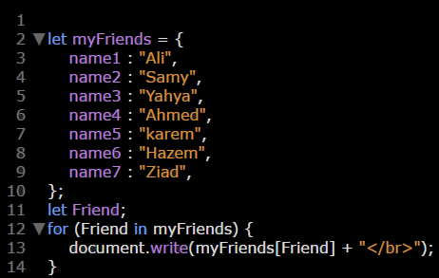

**Example3:**

